**Testing URL for Pixel testing :**

**http://additionalwin.com/pixel.php**

**http://additionalwin.com/result.php**

1. **ace_affiliate_tracking** table contains affiliate casino Id in column affiliate_id
2. **tblPixelQueue** Contains affiliate casino id
3. **tbleServerPixelLog** contains affiliate casino id
4. **tblServerPixelFail** table contains affiliate casino id
5. pageid for deposit = 1 and signup=2

**These are tables for checking pixels**

SELECT * FROM aceaff.tblPixelMaster where affiliate_id= 15381;

SELECT * FROM aceaff.ace_affiliate_casino_link where affiliate_ID = 15381;

SELECT * FROM tblServerPixelLog where affiliate_casino_id = 16621 order by entrydate desc;

SELECT * FROM tblPixelQueue where affiliate_casino_id=16621 order by entrydate desc;

SELECT * FROM tblPixelServerParameters where affiliate_casino_id =15381 order by entrydate desc;

SELECT * FROM tblDepositStatus where affiliate_casino_link_AID = 16621 order by entrydate desc;

SELECT * FROM tblPixelServerFail where affiliate_casino_id = 16621 order by entrydate desc

SELECT * from aceaff.ace_affiliate_tracking where rtg_ar='RAC5a977c35f9689d5fe21f0259b1283624'

**Sign UP Pixel**

1. Add pixel from affiliate manager page w.r.t any affiliate Id e.g. 13167
2. 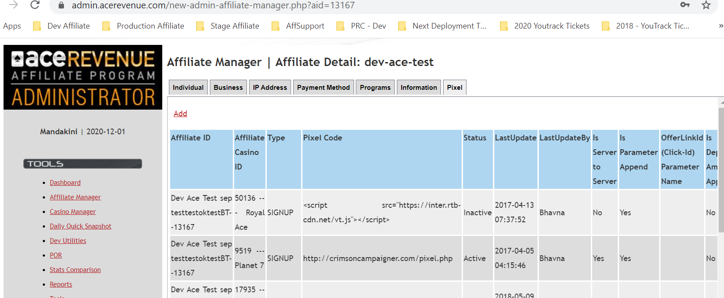
3. Login to affiliate site with same aff Id > navigate to Marketing Tool >Creative> Click on .eu link e.g. for casino Id=1(Silver Oak )<http://stage.silveroakcasino.eu/click/1/8713/13167/1>
4. Once we click on .eu link it will create tracking id and will store in ace_affiliate_tracking table.
5. Do a sign up.
6. After sign up , first it will be inserted into tblPixelQueue table wr.t affiliate_casino_id

andStatus =0

SELECT * FROM aceaff.tblPixelQueue where affiliate_casino_id = 16621 order by entrydate desc

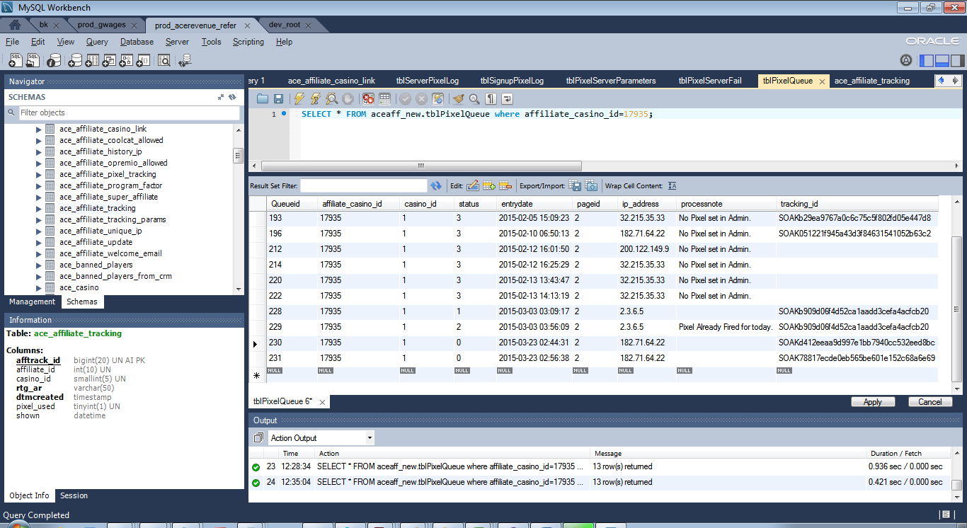

1. Once the job ran it will change the status =1 if pixel is successfully fired in tblPixelQueue table and at the same time it will be inserted into tblServerPixelLog with status=1
2. SELECT * FROM aceaff.tblServerPixelLog where affiliate_casino_id = 16621 order by entrydate desc

Note : Only successfully fired pixel entry will be inserted in to tblserverPixelLog table

Status=2 ( if it is already fired for Today)

Status =3 ( if pixel is not set in Admin)

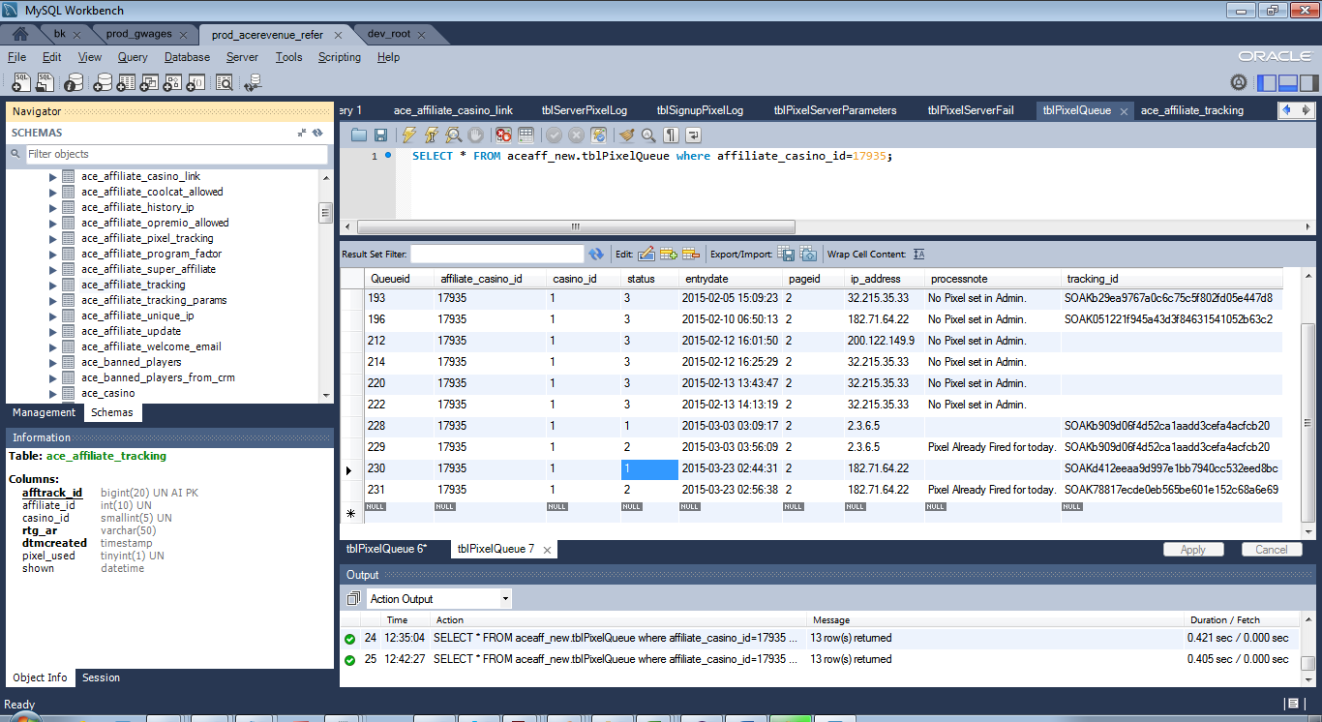

tbleServerPixelLog:

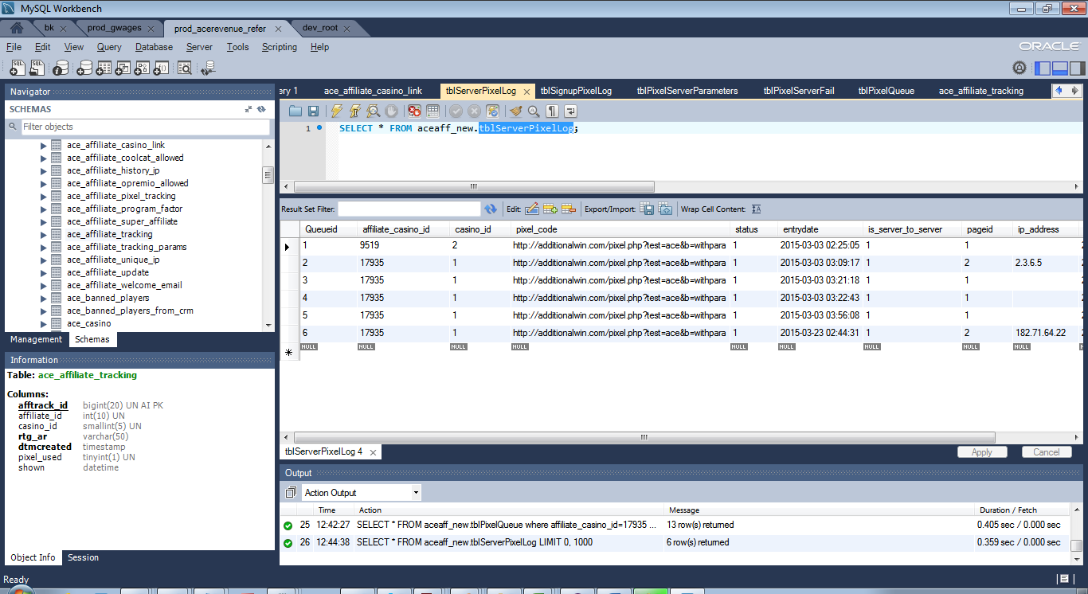

1. If pixel is not successful due to some reason , it will still inserted with Status =0 in tblPixelQueue

Once the job ran Status column=1 in tblPixelQueue

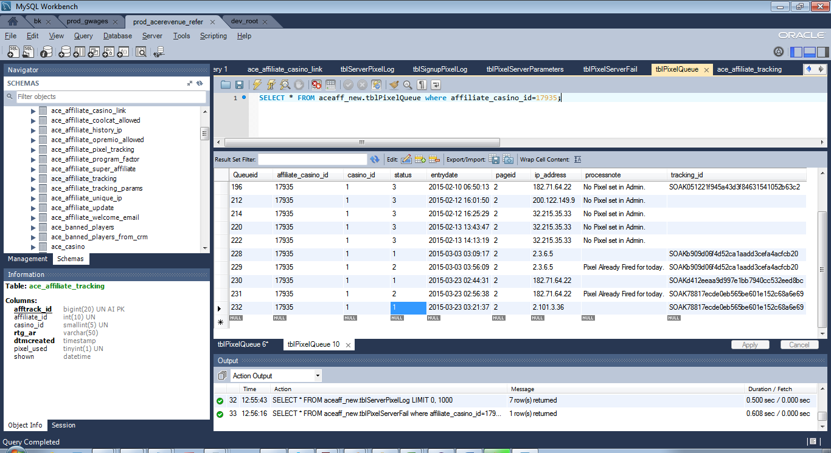

and entry will be inserted to tblServerPixelLog with Status =1

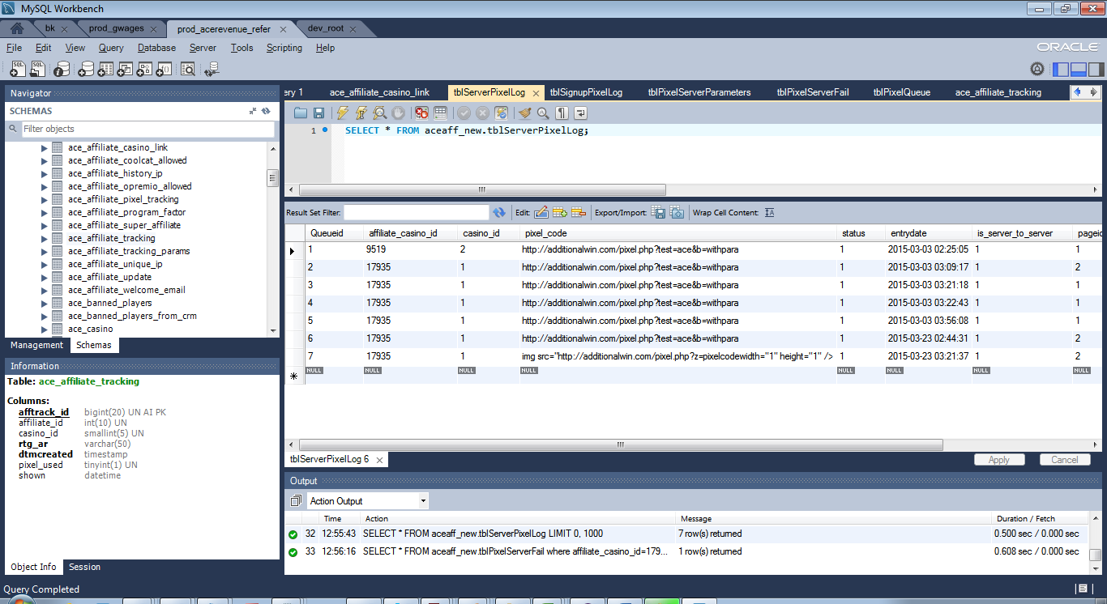

At the same time entry will be inserted in to tblServerPixelFail table with Status =0 and Casino Id=1(it is for silver oak )

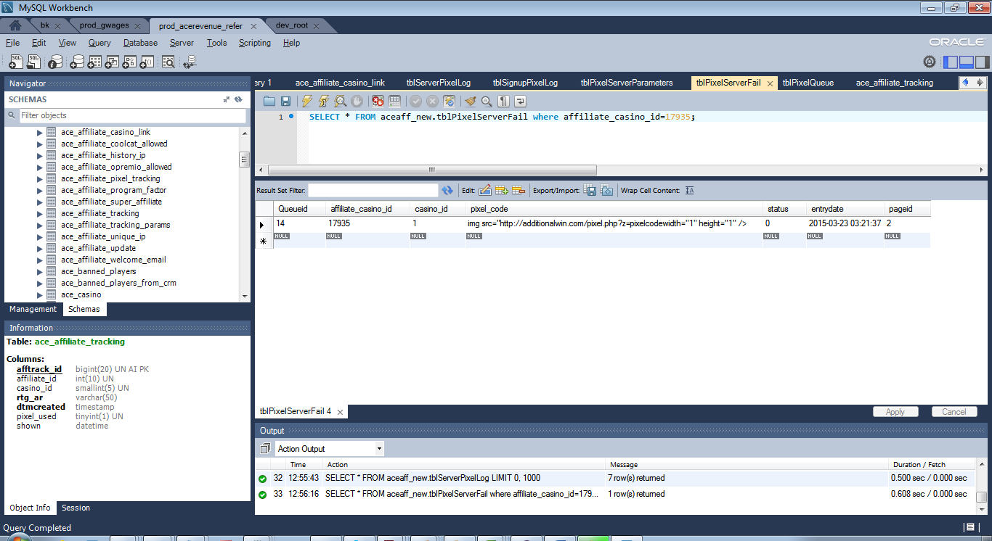

1. When Failed job will run and it will look the data in tblServerFailed table for the Status =0 row and if it again fails it will change the casino Id=0 and status will remain 0

In case of success Status =1 and casino id =1

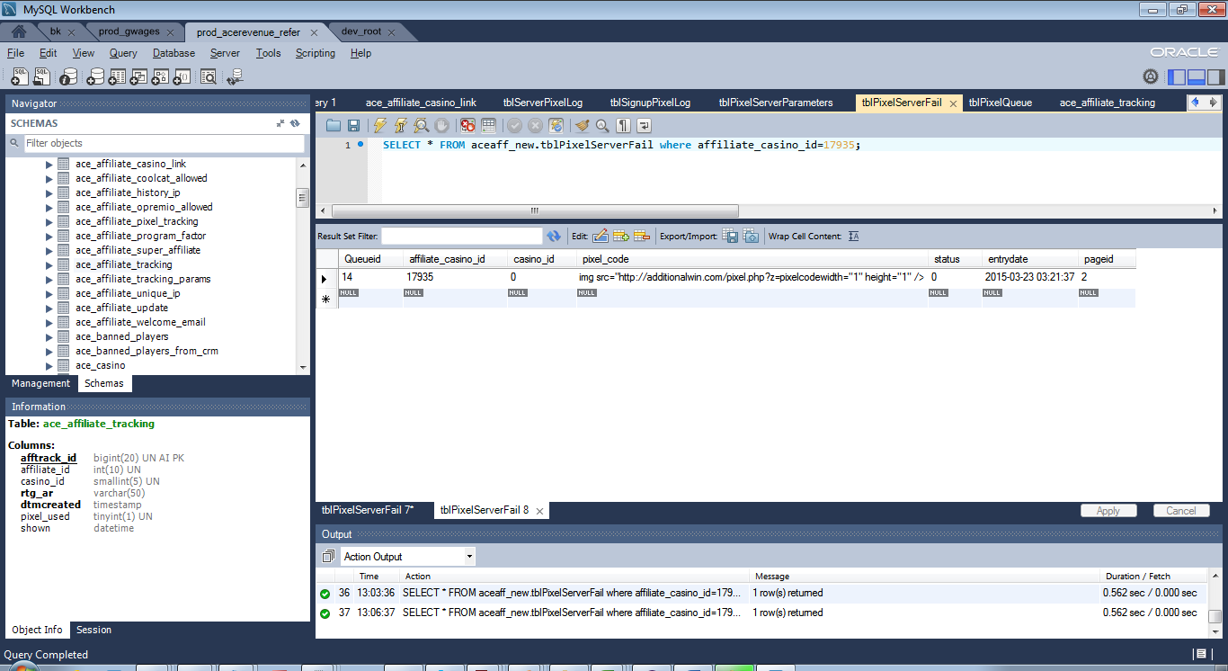

Note :

**With same IP address signup pixel is executed only once in a day.**

**Deposit Pixel**

**TICKET : AFF-239 Doughflow Server to Server Deposit Notification**

1. Add a deposit pixel in Admin > Pixel Tracking Tool w.r.t any affiliate Id e.g. 13167
2. Before 1st deposit pixel fire w.r.t some tracking id , in ace_affiliate_trackingPixel_used column value should be 0

And in tblDepositStatus table there is no row for that particular tracking id

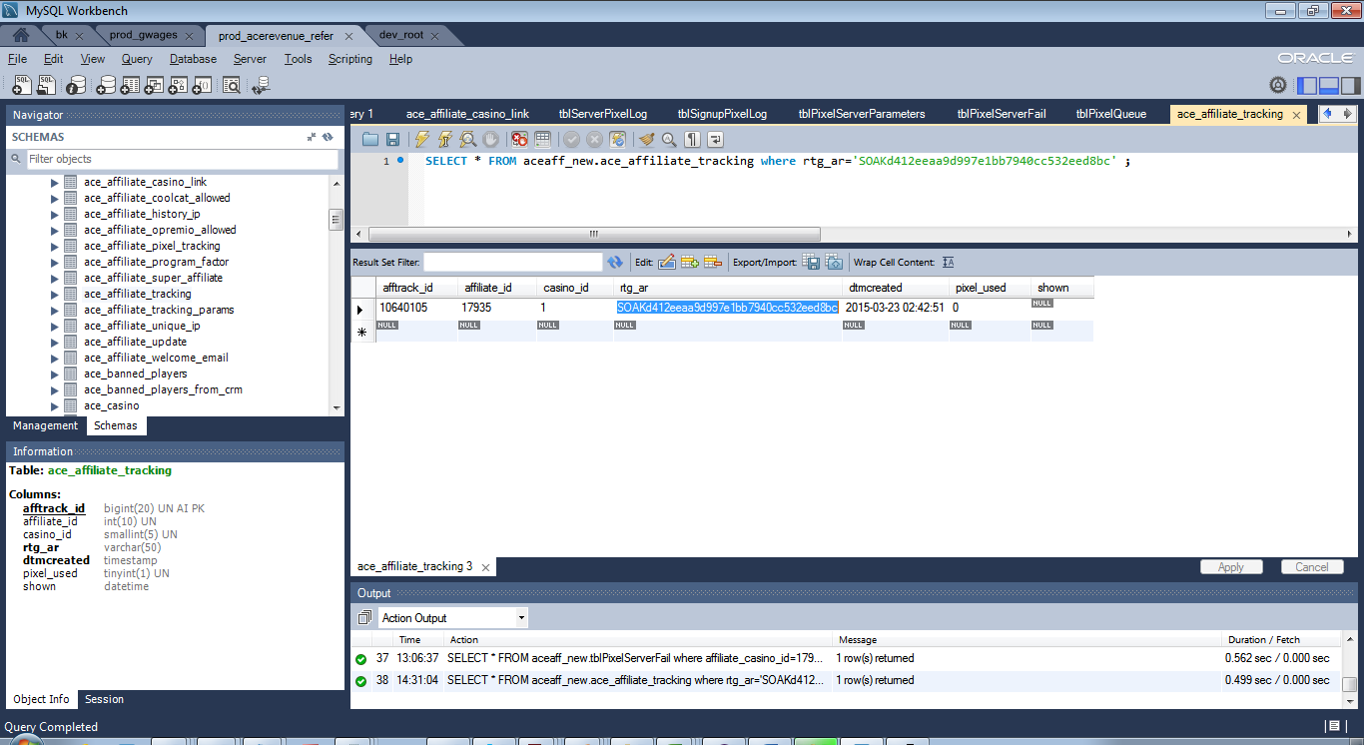

**tblDepositStatus**

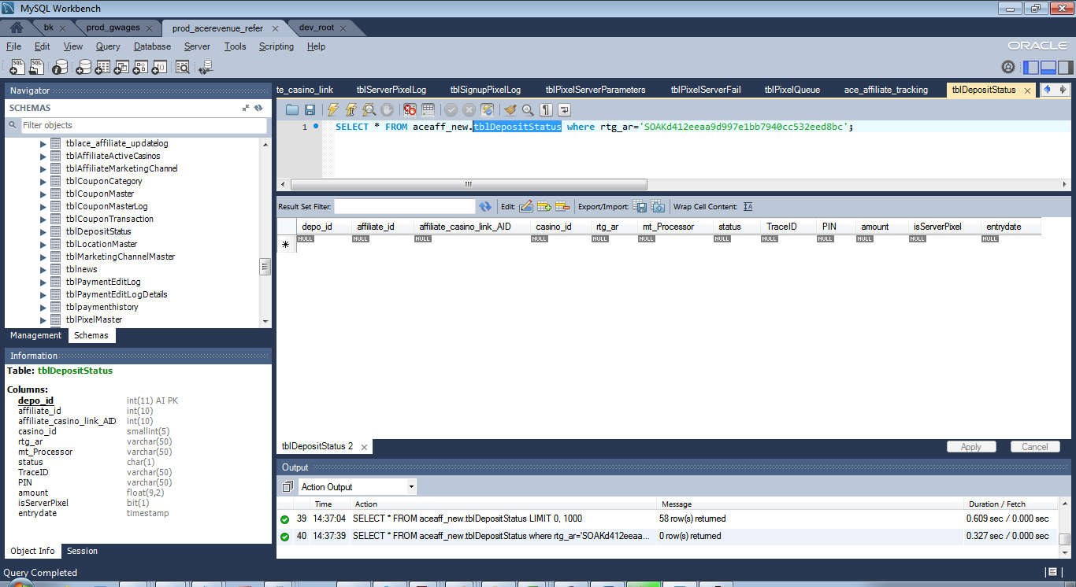

3 . Perform a deposit and deposit pixel will fire .

Following entries should be added :

In ace_affiliate_tracking table > pixel _used column value will be 1

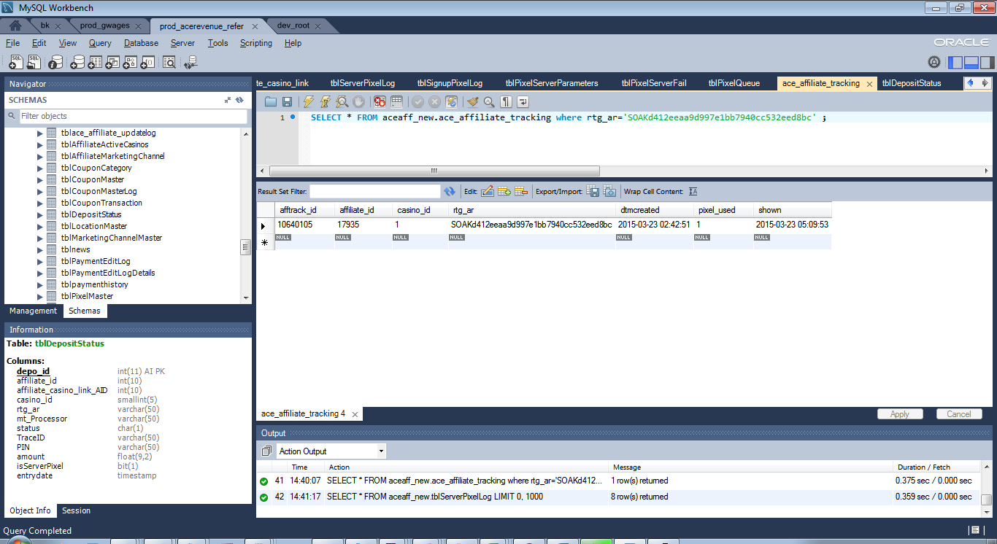

A row with status =0 is added in tblServerPixelLog t able

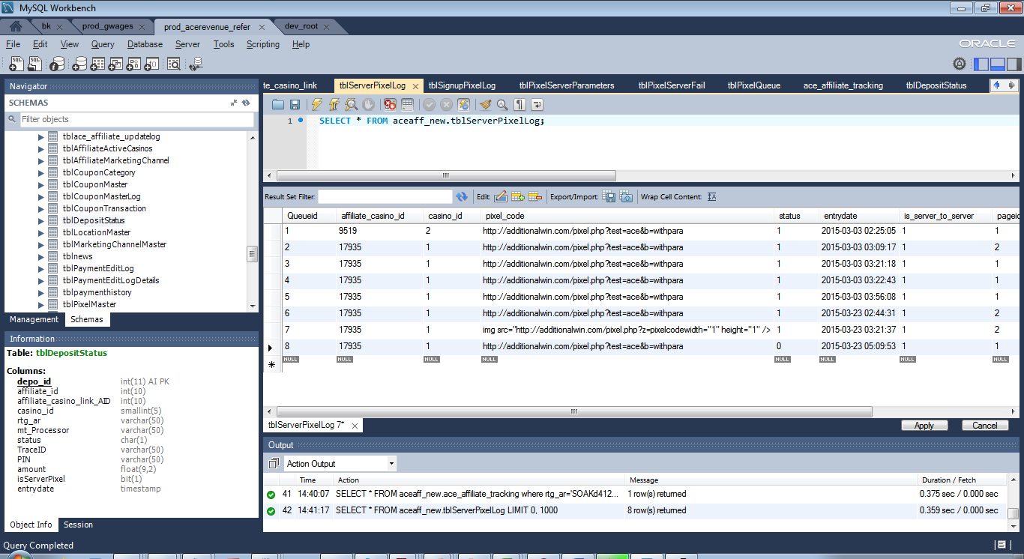

1. Once the job ran and pixel is fired successfully Status =1 in tblServerPixelLog table

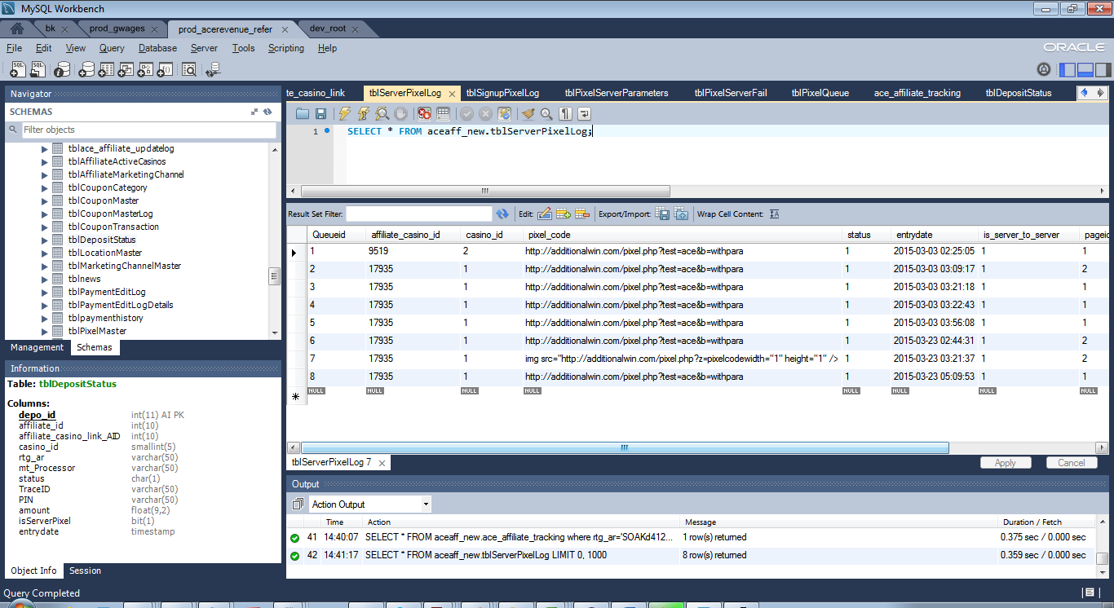

1. In tblDeposit Status table an entry will be inserted to the corresponding rtg_ar (tracking id)

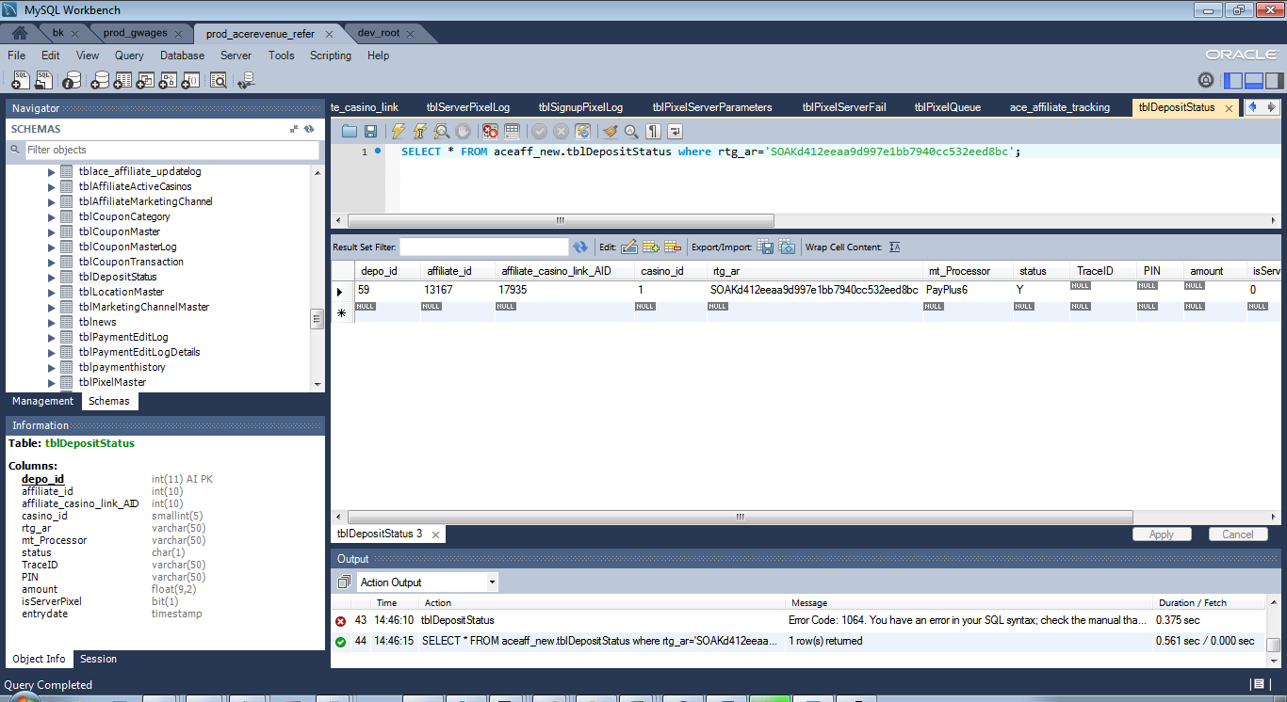

1. If pixel is not successful due to some reason , it will still inserted with Status =0 in tblServerPixelLog

Once the job ran Status column=1 in tblServerPixelLog and after that entry will be inserted to tblServerPixelFail table with status =0 and casino_id=1

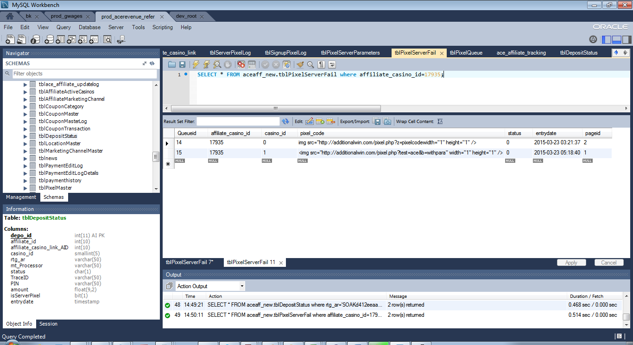

1. When Failed job will run and it will look the data in tblServerFailed table for the Status =0 row and if it again fails it will change the casino Id=0 and status will remain 0

In case of success Status =1 and casino id =1

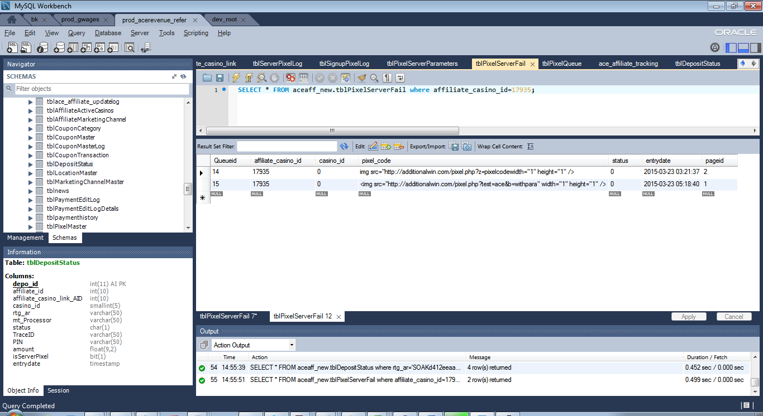

**Note:**

1. **If Deposit pixel is set for First deposit in Pixel Tracking Tool then only first time entry will be inserted into tblServerPixelLog table and in tblDepositStatus table it will be inserted every time when pixel is fired irrespective of first time deposit or All time deposit.**
2. **In tblDepositStatus table column name IsServerPixel =0 means pixel.php ( e.g. http://stage.acerevenue.com/pixel.php?mt=PayPlus6&status=Y&ar=SOAKd412eeaa9d997e1bb7940cc532eed8bc)file is called and**

**IsServerPixel =1 pixelServer.php(http://stage.acerevenue.com/pixelserver.php?pp=PayPlus6&status=Y&trackingid= SOAKd412eeaa9d997e1bb7940cc532eed8bc&traceid=21733852&pin=bhavnastage&amount=10) file is called .**

**Old URLs of deposit pixel: No change in these following pages:**

http://www.gwages.com/pixel.php?mt=PayPlus6&status=Y&ar=CCC509ad635b9b53948e885d3052870b39b

http://www.acerevenue.com/pixel.php?mt=PayPlus6&status=Y&ar=SOAK43fafdb30c29fbf9dc3b7b51b9d7998f

**New URLs of deposit pixel:**

http://www.gwages.com/pixelserver.php?pp=PayPlus6&status=Y&trackingid=CCCb7bfecf2f97dc9e90eff3616f7efa026&traceid=21733852&pin=vipin111&amount=50

http://www.acerevenue.com/pixelserver.php?pp=PayPlus6&status=Y&trackingid=SOAK52f27520f6b44616f1706c79531139e0&traceid=abcdefg&pin=bhavnatest&amount=20

**URLs for Signup pixel:**

<http://www.acerevenue.com/signup_pixel.php?aff_id=16621&trackingid=LBC6d3b847800e598e73f53ab90e919ce7b&ip=127.0.0.1&casino_id=21>

**On Casino End following API is calling for client side pixel to get dynamic parameter.**

<https://www.acerevenue.com/apipixelparameter.php?trackingid=SOAK0bff95c04aa9295ee6b7dcc6876675ca>

This is the code on casino site

<?php

if($_SESSION['affid']==2652 || $_SESSION['affid']==2651){

$dynamicparameter = file_get_contents('https://www.acerevenue.com/apipixelparameter.php?trackingid='.$_SESSION['trackingID']);

$dynamicparameter = json_decode($dynamicparameter);

$iframeurl= "http://clicks4wins.com/path/frame.php?".$dynamicparameter->affiliate_parameters;

echo '<iframe src="'.$iframeurl.'" id="apipixelparameter" name="apipixelparameter" width="0" height="0" frameborder="0" style="position:absolute; top:0; right:0;"></iframe>';

}

?>

this iframe loads in a page that exists between form processing and final destination (cashier for desktop or mobile lobby)