1. Access VIP detail is incorrect for Titanium and platinum

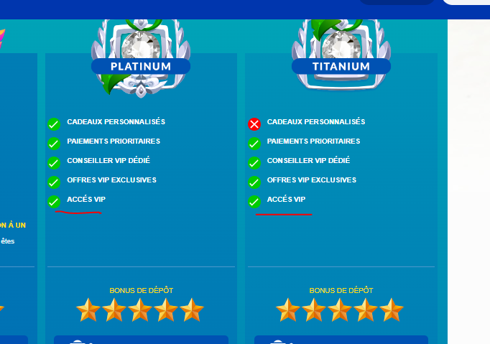

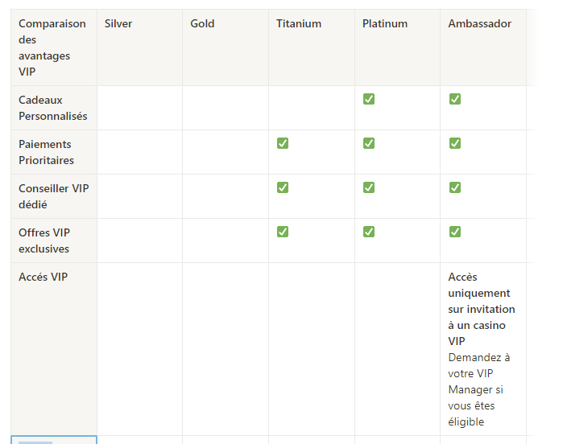

1. Comma to be replaced by dot for 12.5%

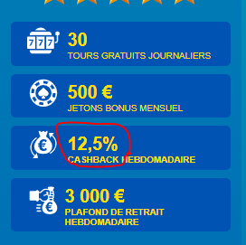 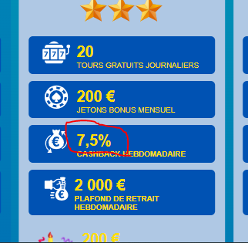

1. Weekly cashback is missing

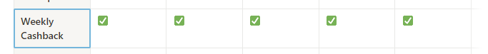

1. Par semaine is missing

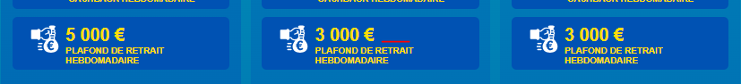

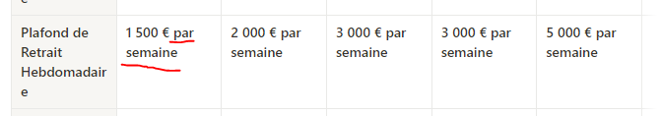

1. Please add space between client and est

